**AWS:**

1. **AWS login screen with username**

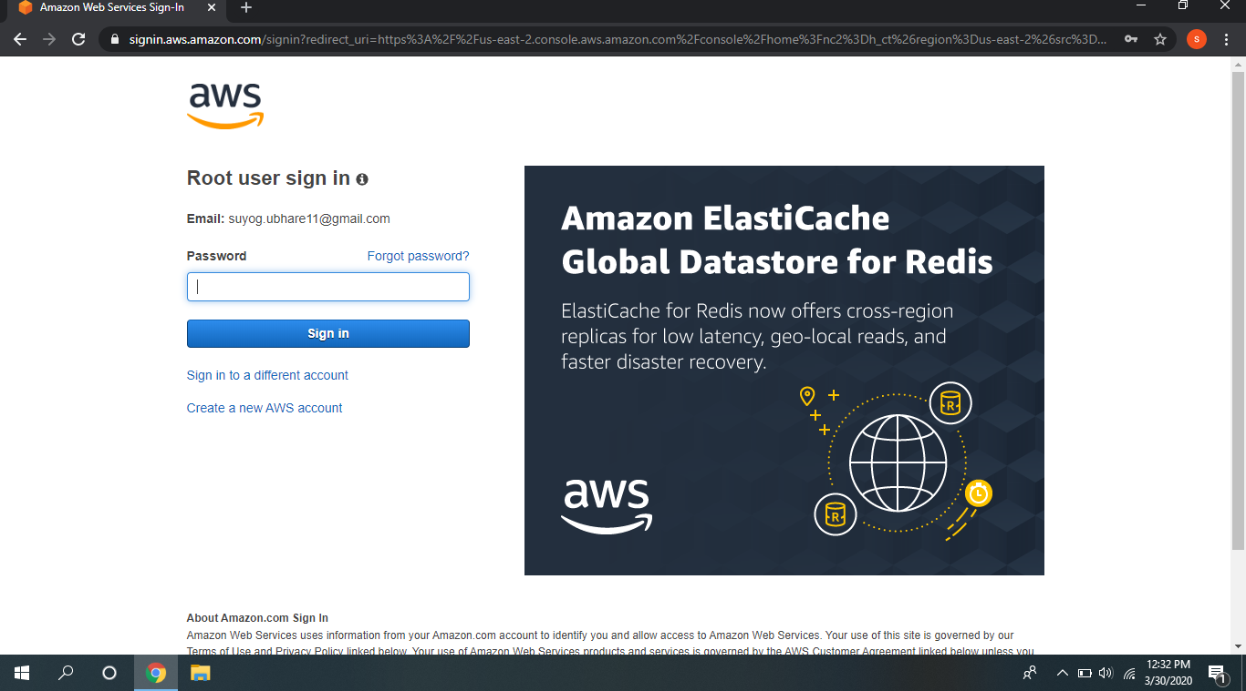

1. **EC2 Dashboard:**

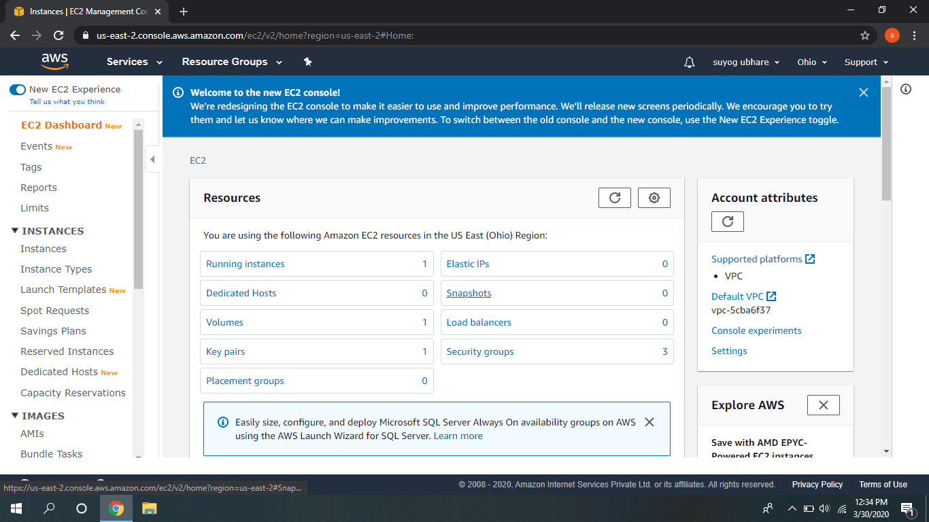

**C. S3 Dashboard:**

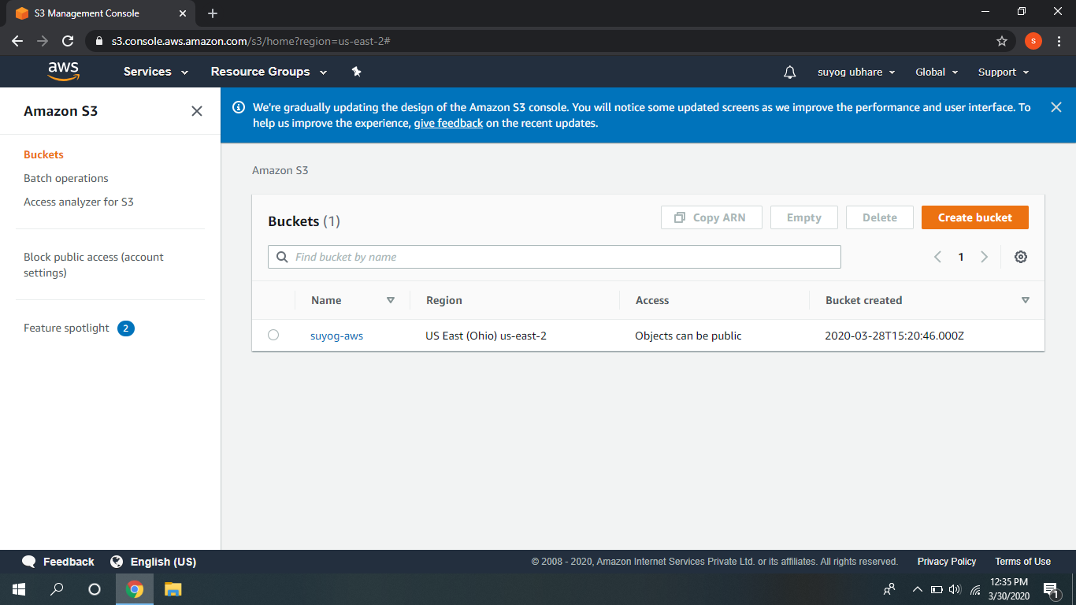 **d. Rekognition Dashboard:**

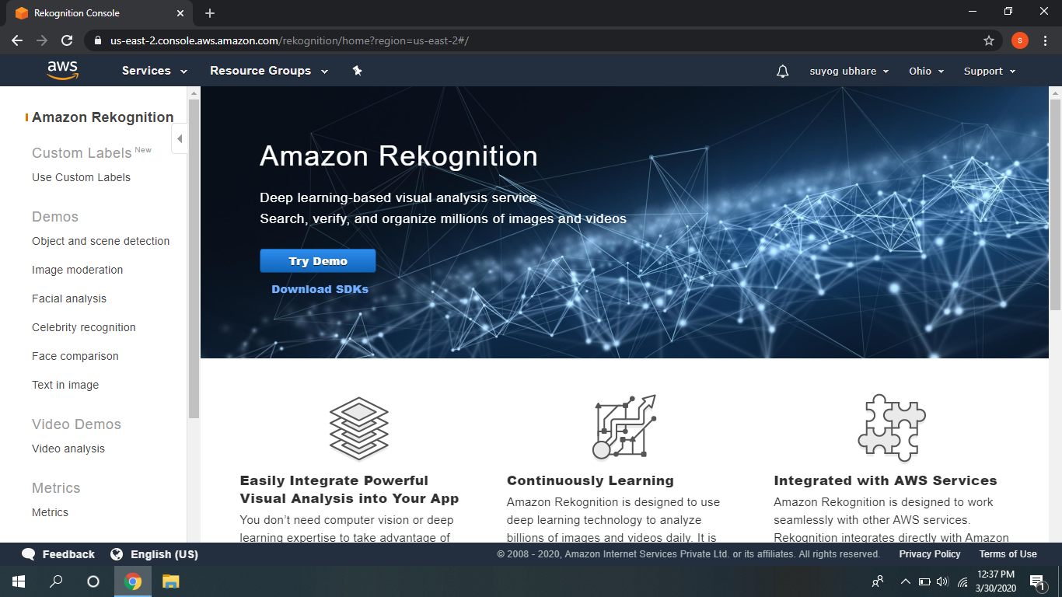

**Ec2:**

**a. Choosing an AMI:**

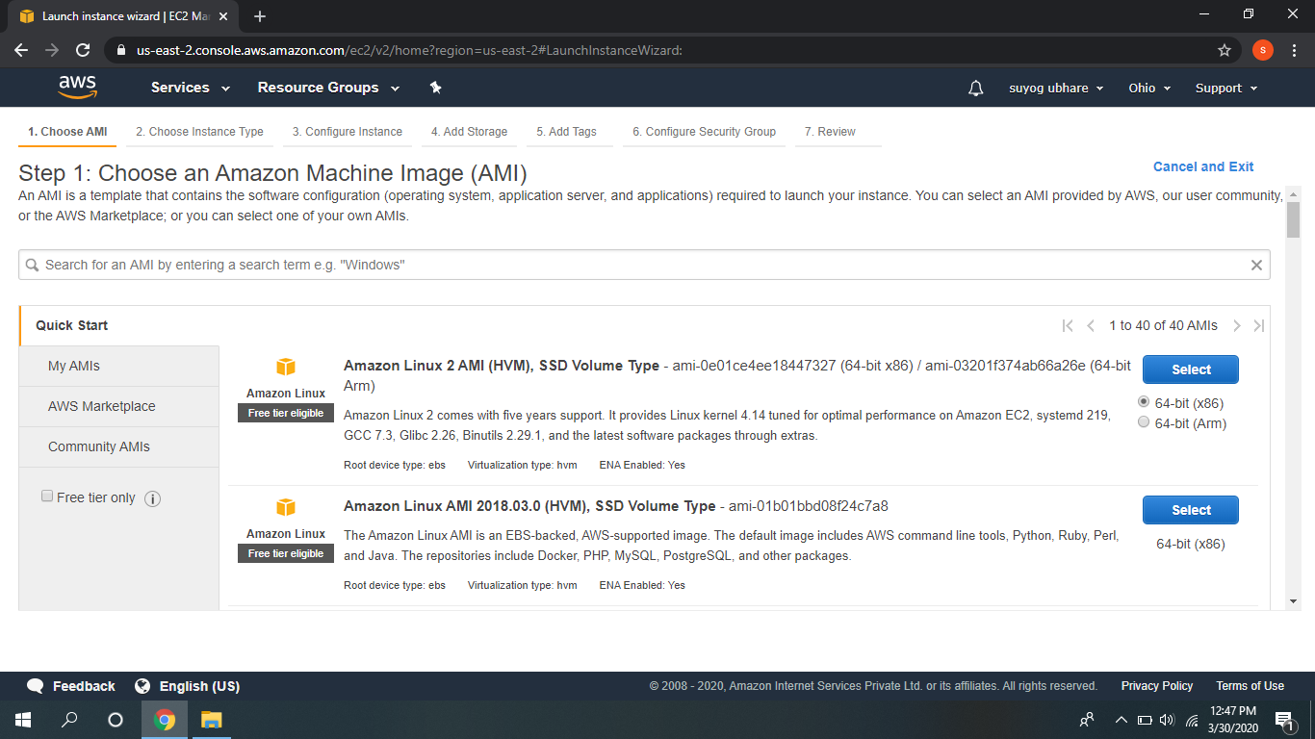**b.Choosing an instance type:**

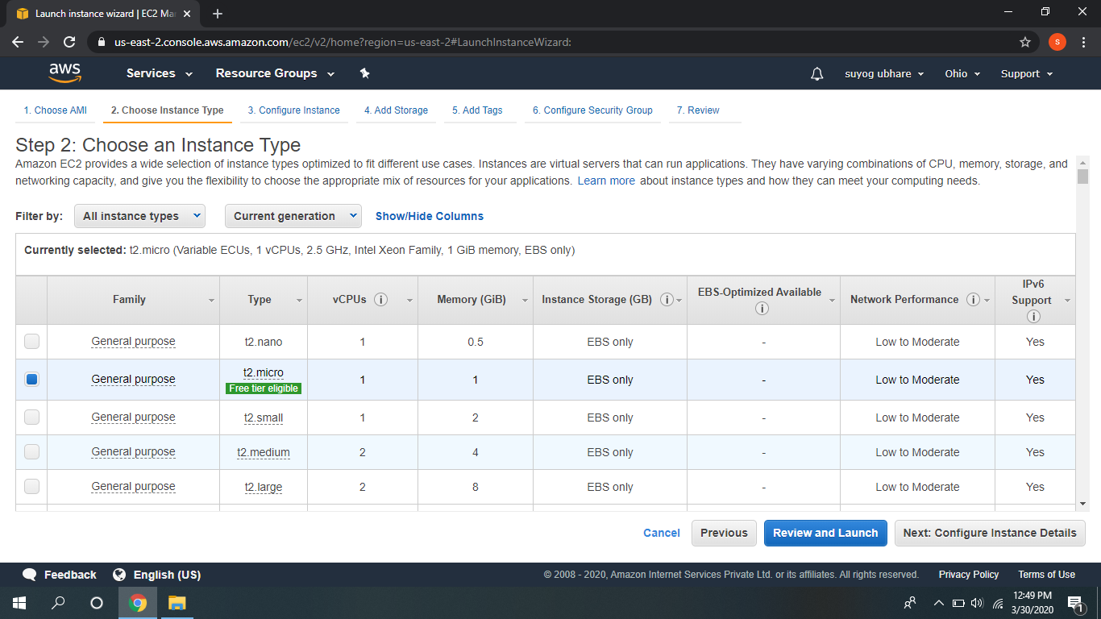

**C .Adding Storage:**

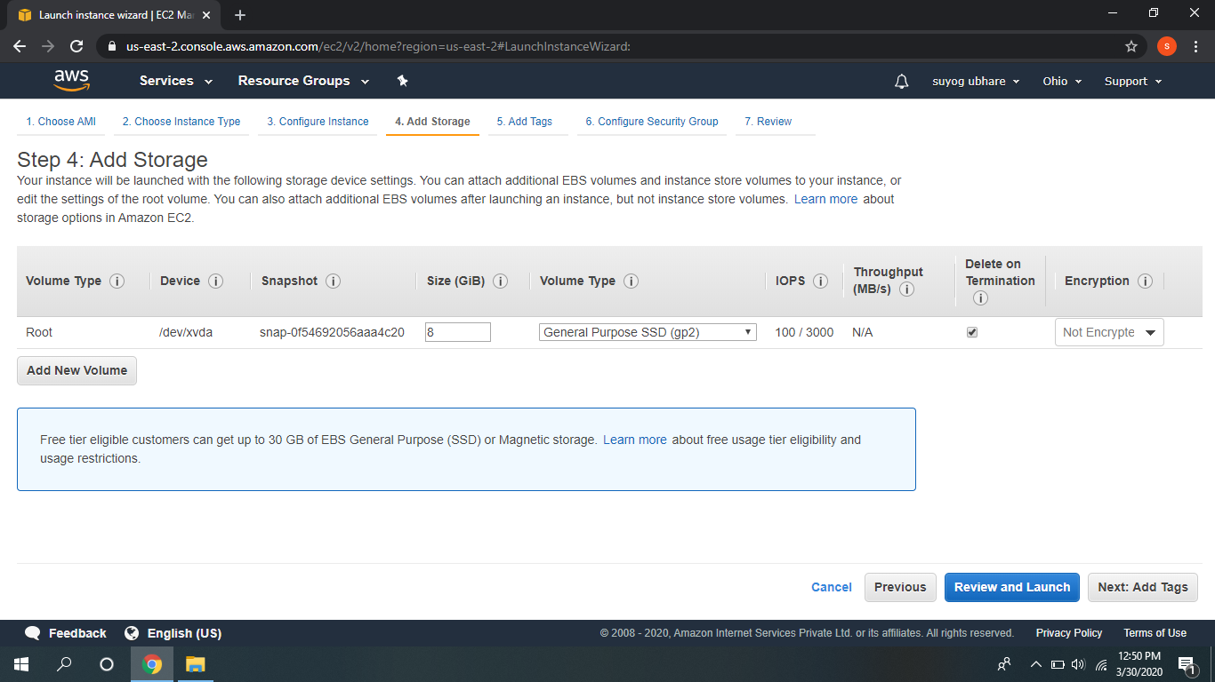

**d. Configuration security group:**

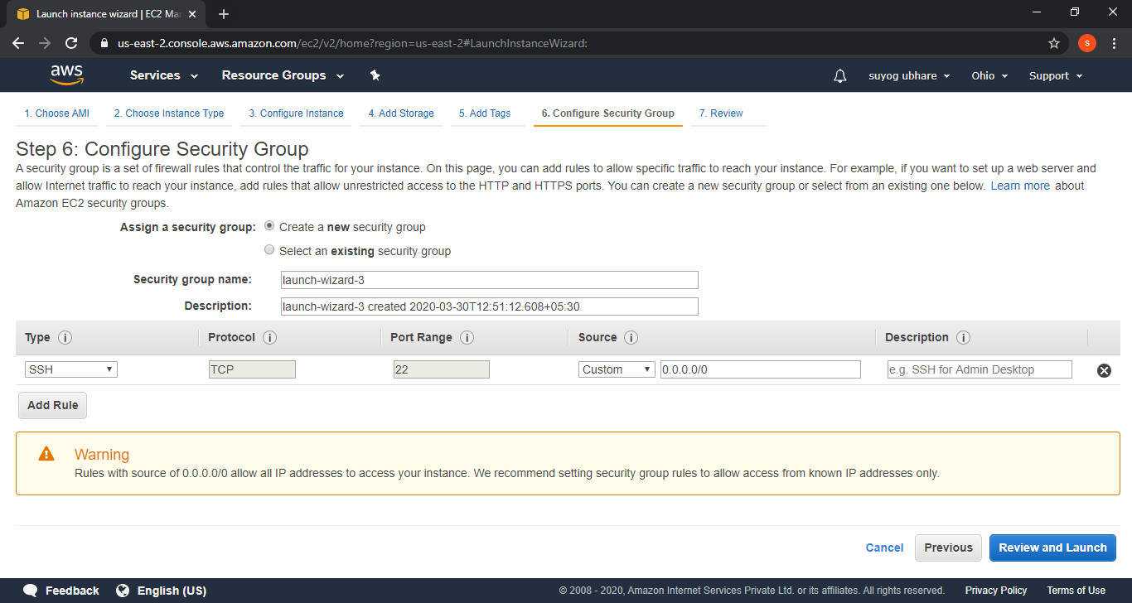

1. **Key pair Download:**

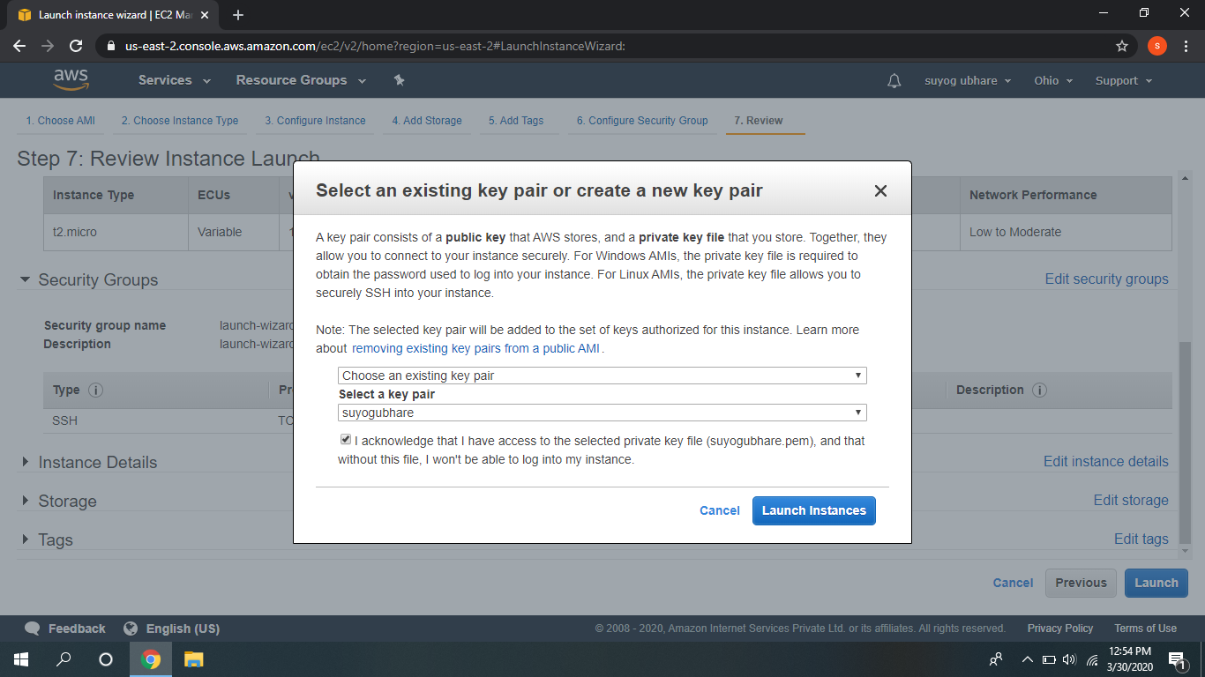

1. **Puttygen conversion from pem to ppk:**

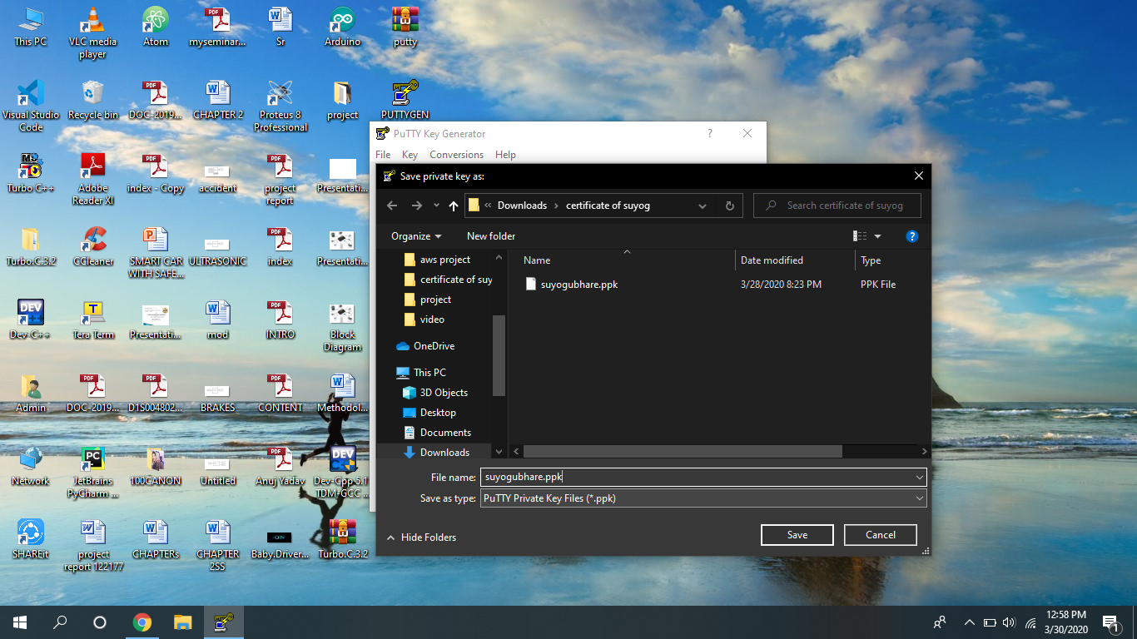

1. **Logged in Ec2 black screen:**

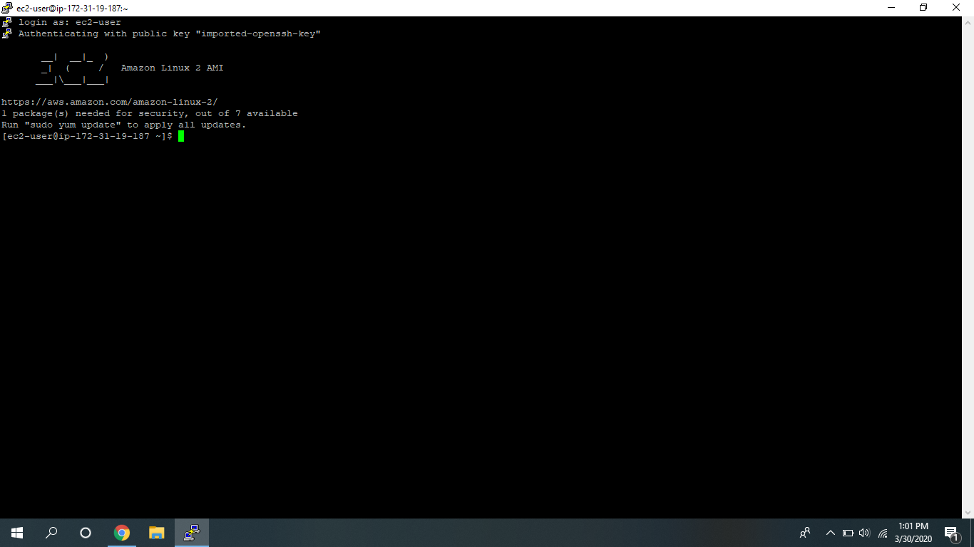

S3:

1. **Creating a bucket:**

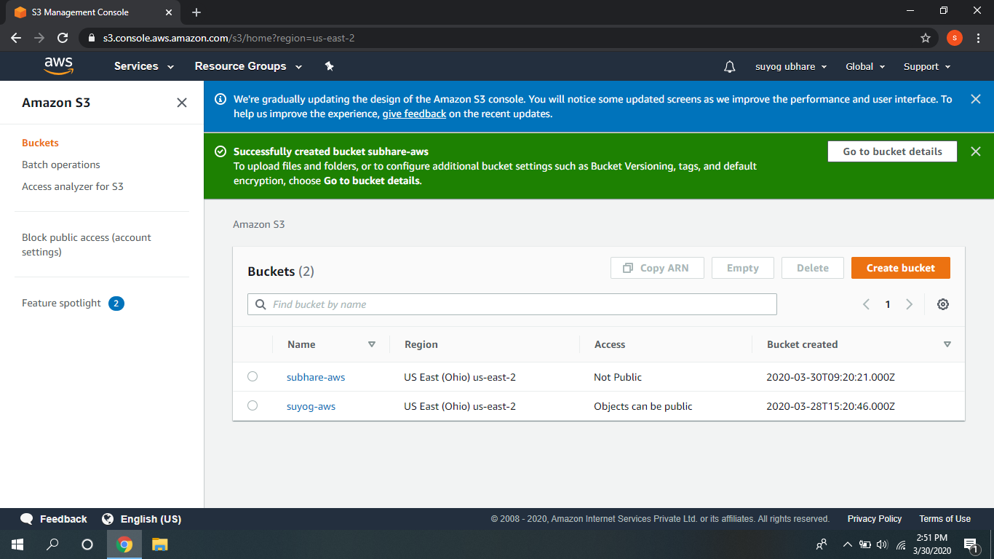

1. **Uploading an object:**

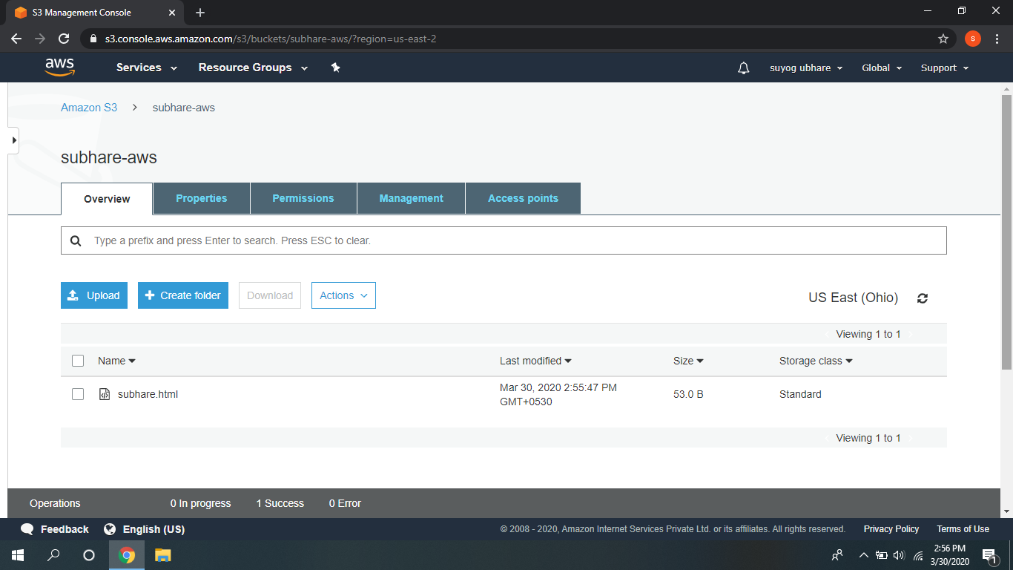

1. **Enabling static website:** 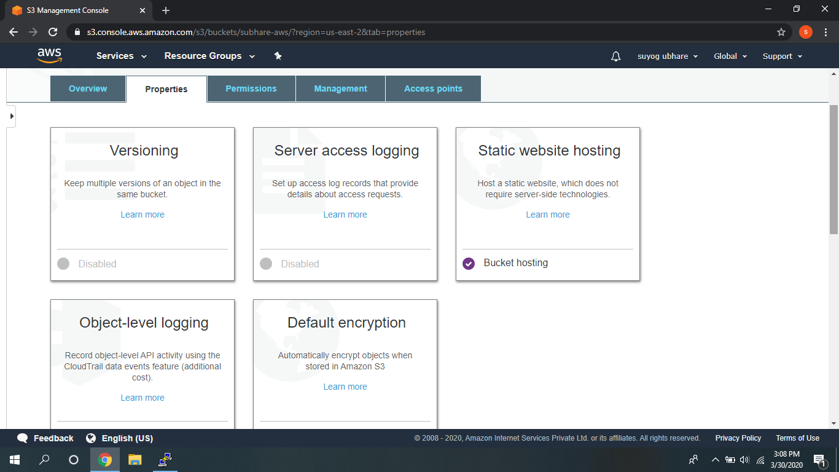
2. **making the object public :**

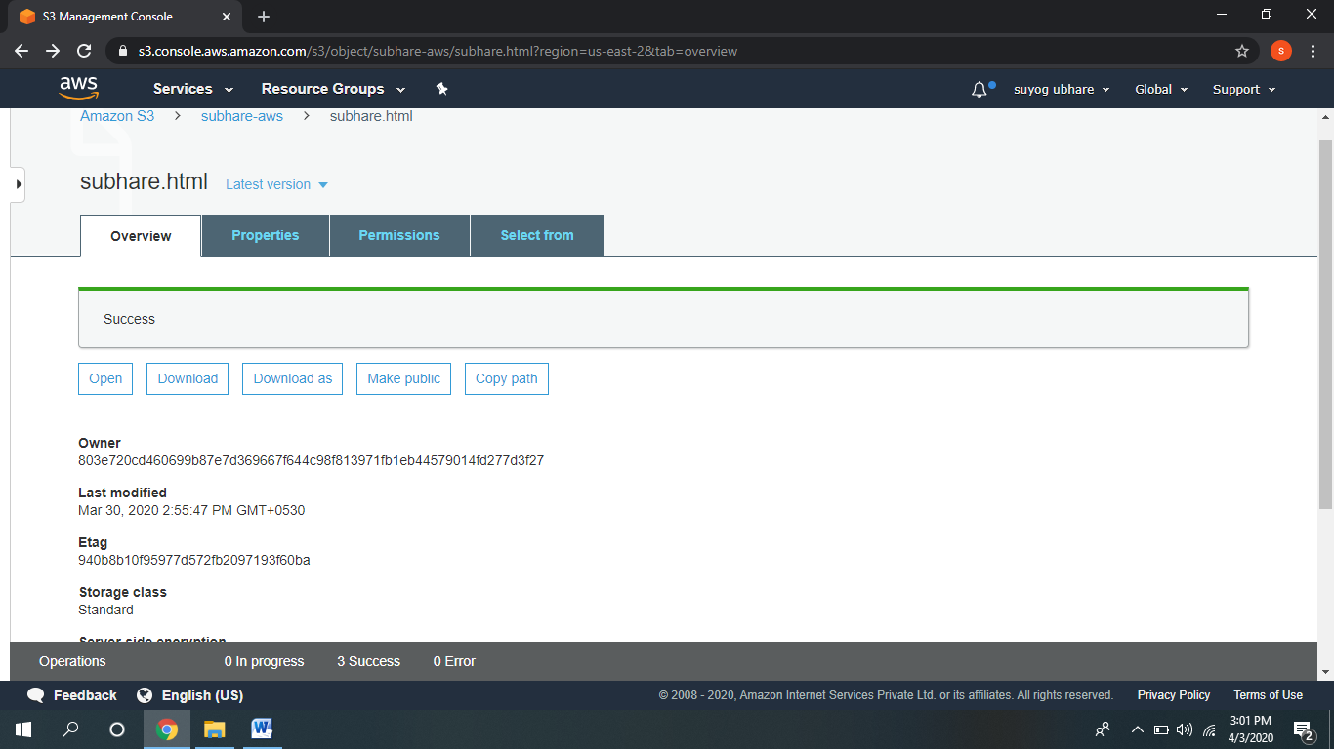

1. **Checking the S3 link on the browser:**

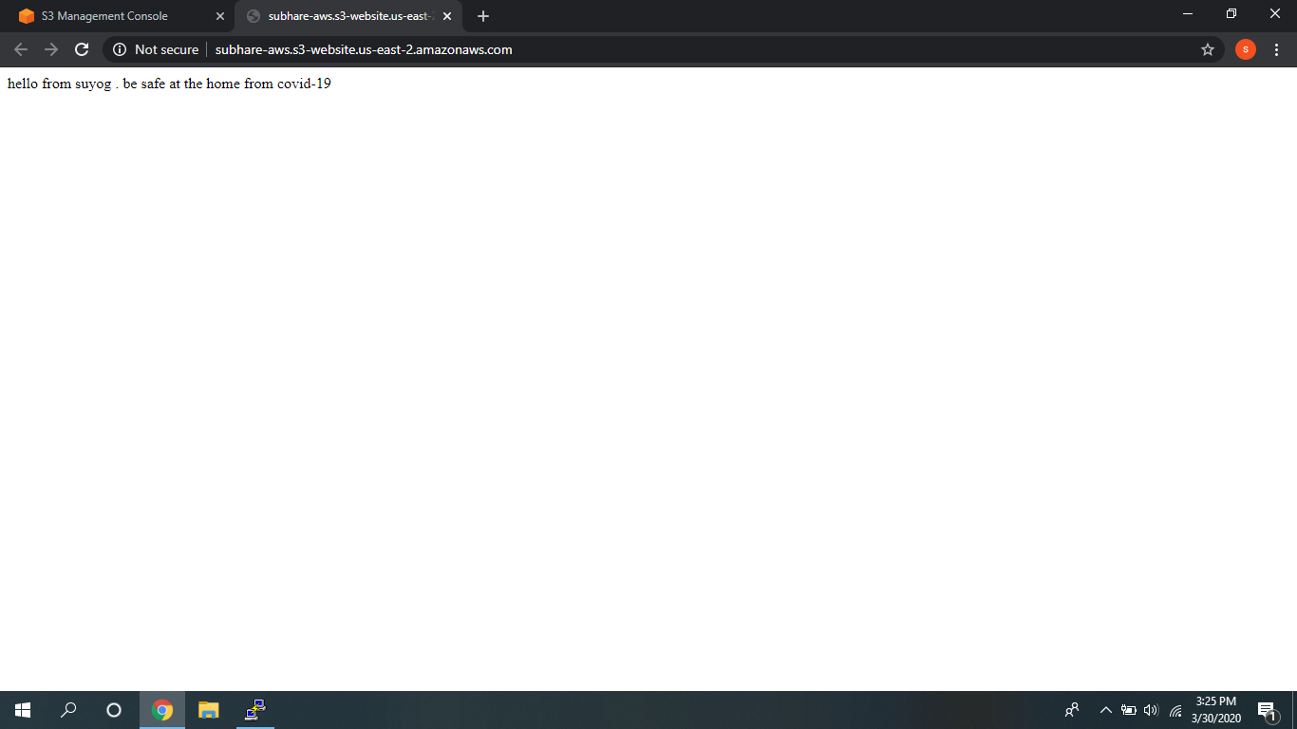

**Rekognition:**

1. **Face Detect:**

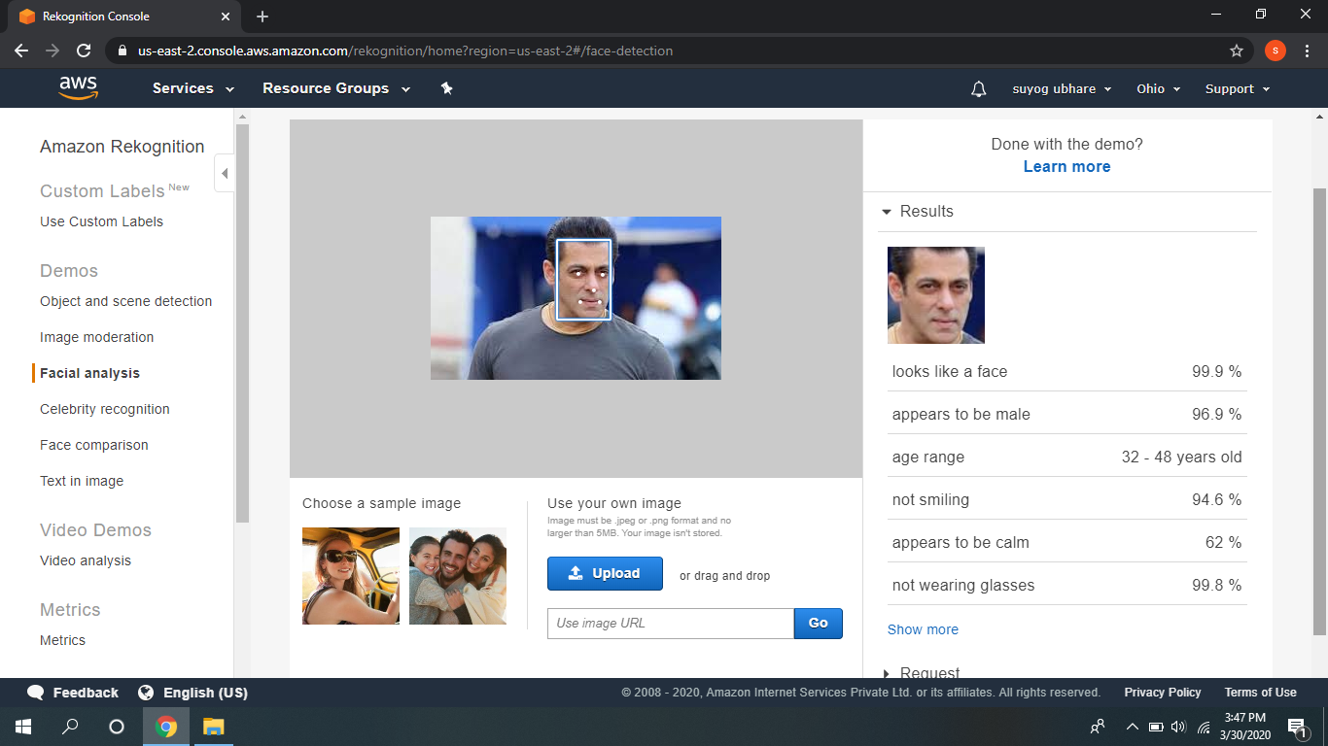

1. **Face compare:**

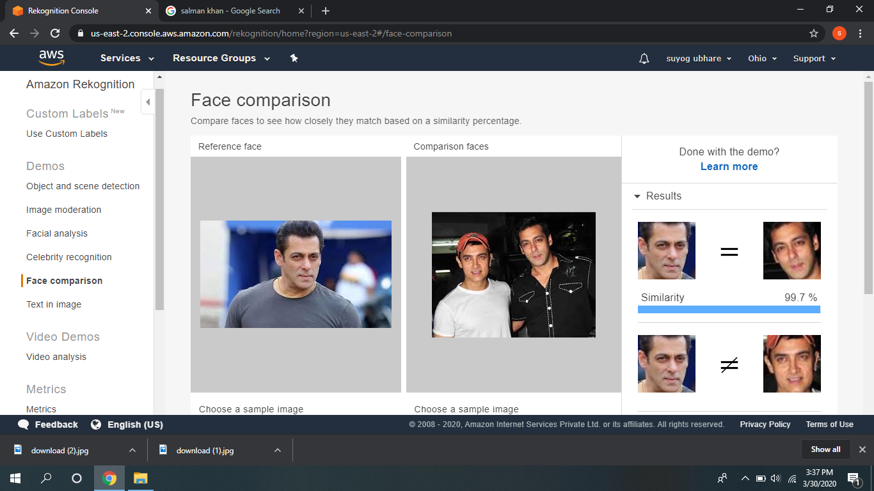

1. **Celebrity Recognition:**

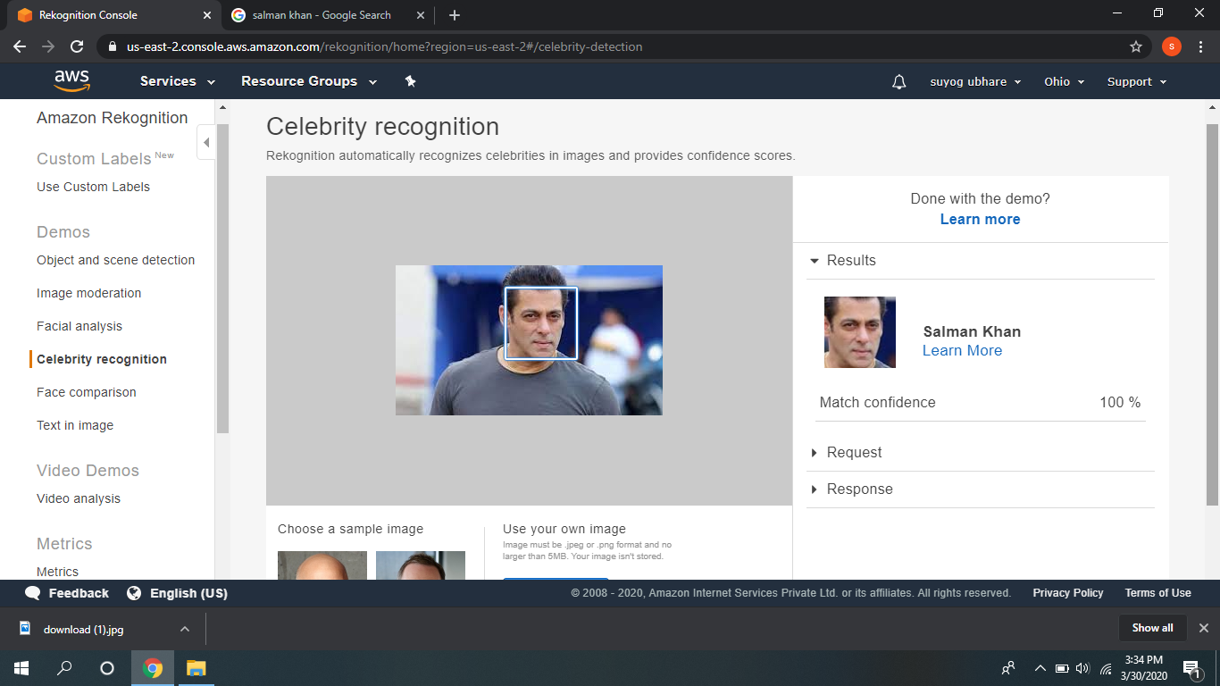

1. **Text in image:**

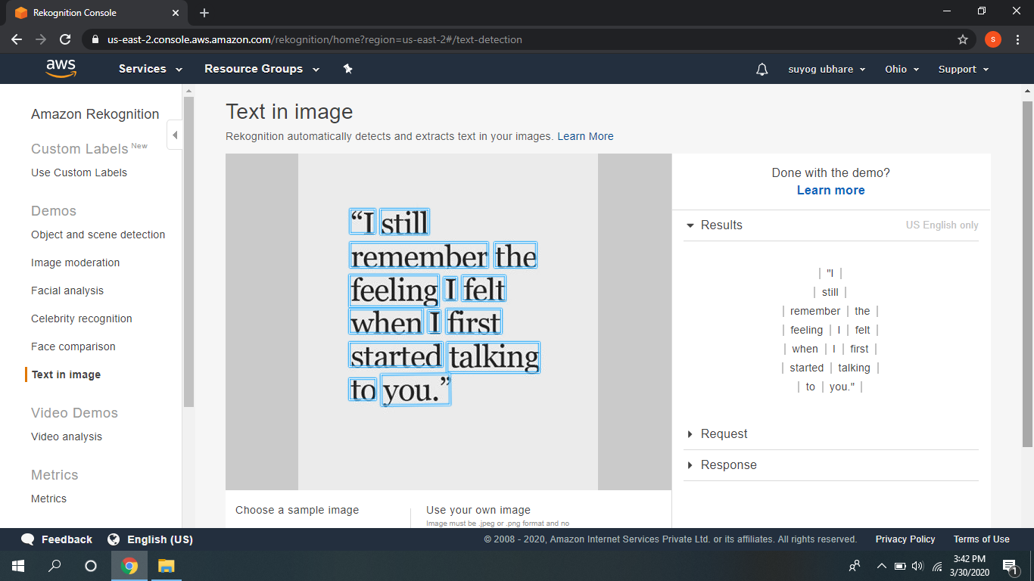

**Ec2 and s3:**

1. **Installing aws-sdk:**

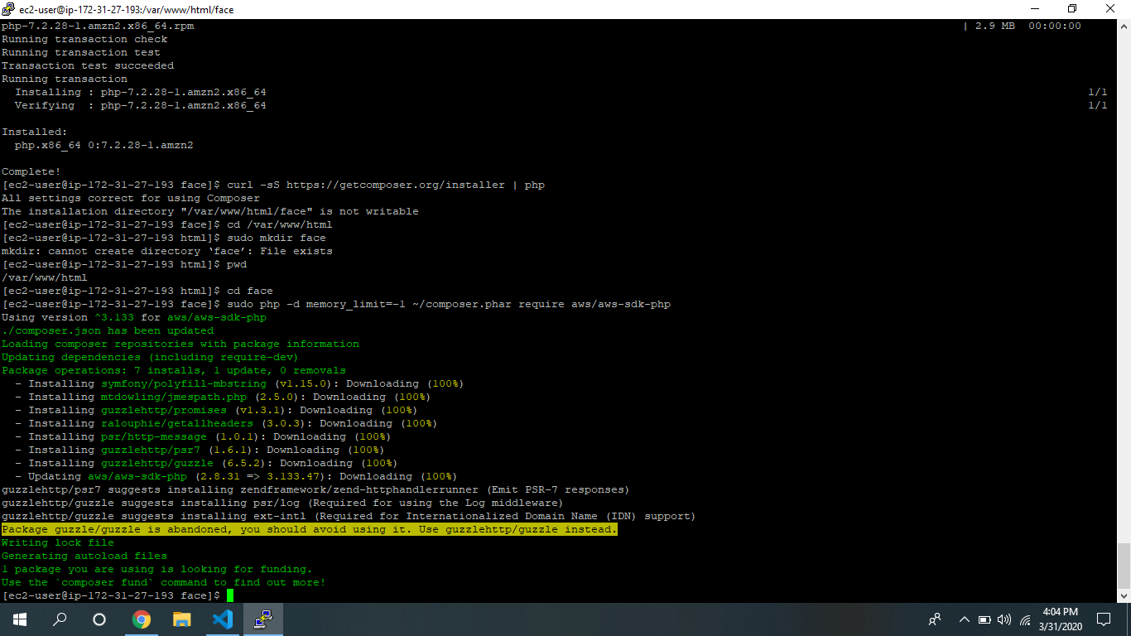

1. **Installing php:**

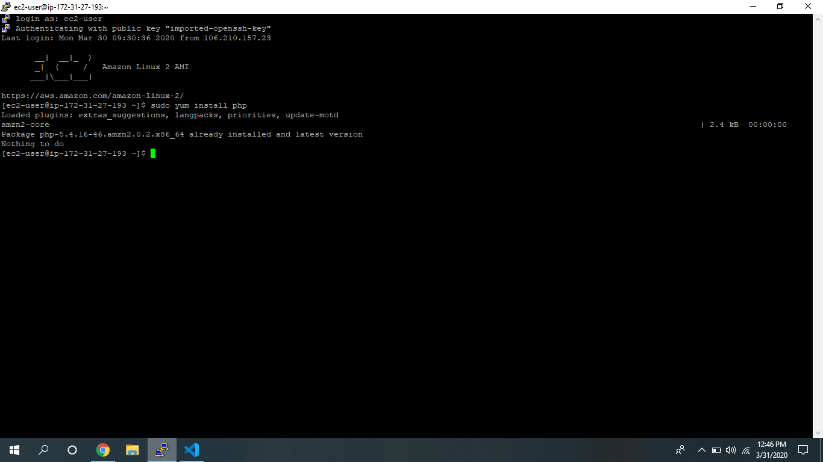

1. **Index.php file code:**

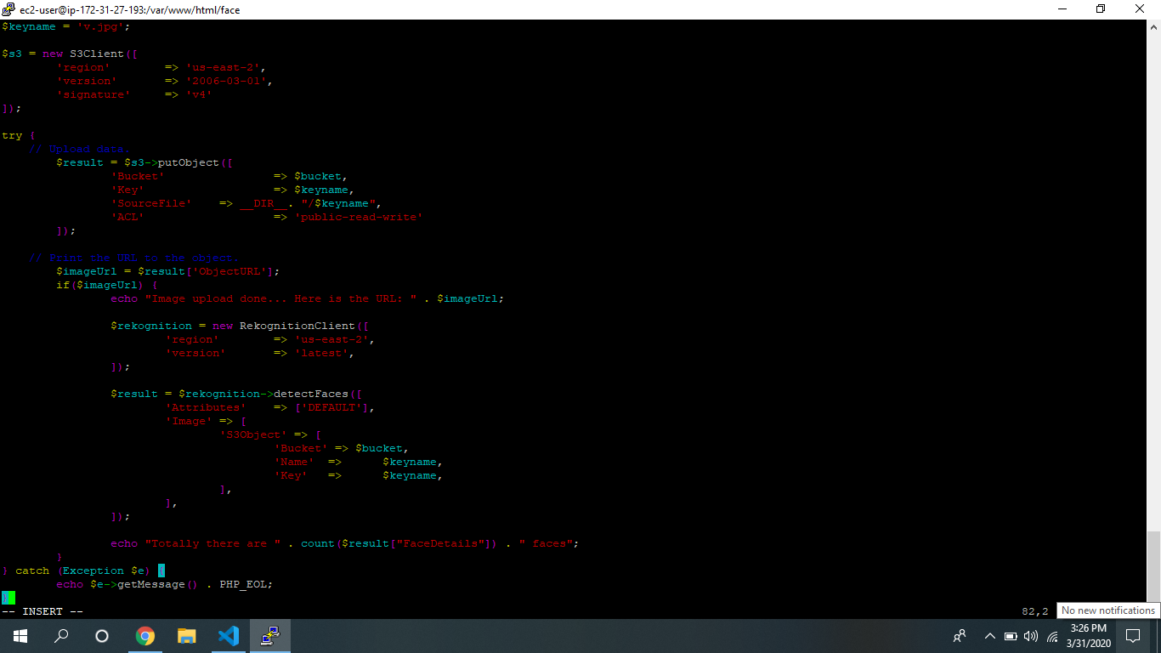

1. **Upload success screenshot:**

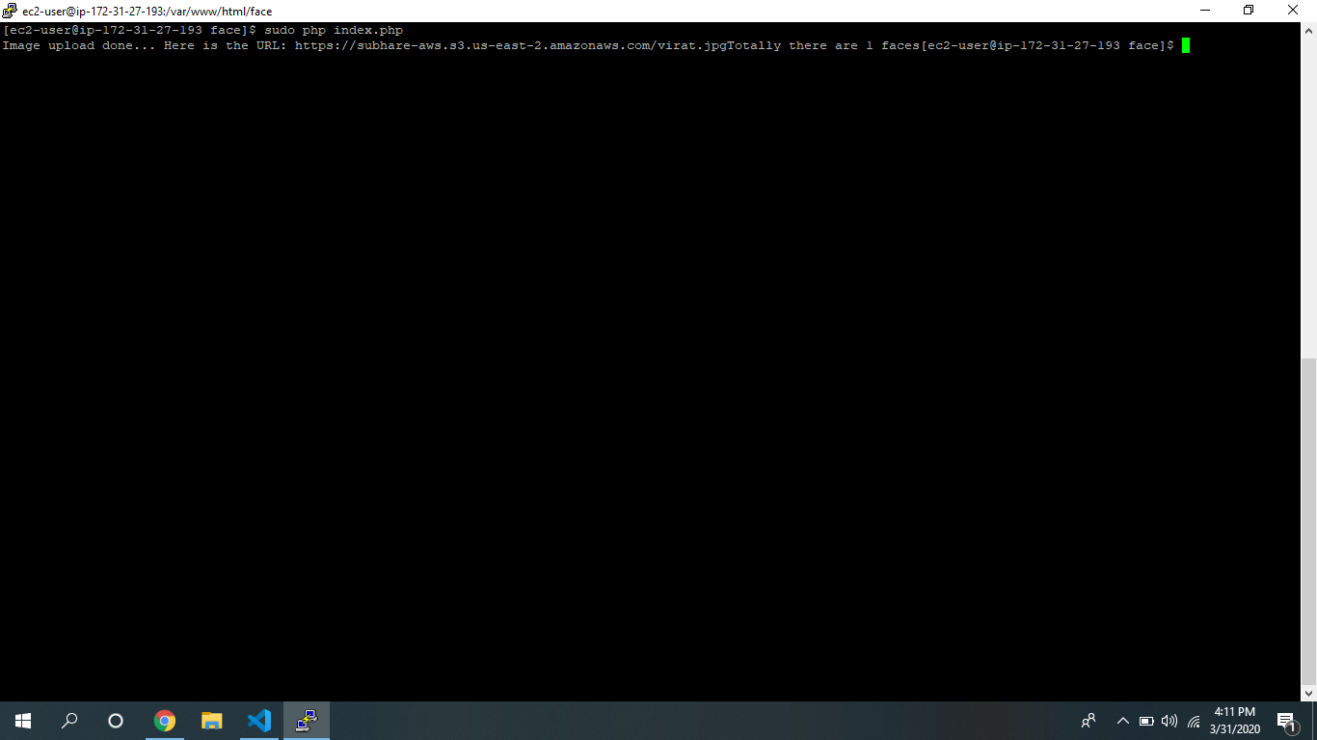

**Ec2 & Recognition:**

1. **Face detect success screenshot:**

